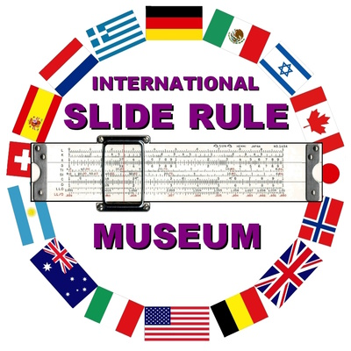
May 4, 2023
Future of Accessioning, Deaccessioning, Transfer and Disposal
All specimens gifted to the International Slide Rule Museum (ISRM) archives are given accession numbers. Accessioning is the process of creating a permanent record of an object, assemblage, or lot received from one source at one time for which the Museum has custody, right, or title, and assigning a unique control number to said object, assembly, or lot. As part of ISRM's mission, specimens received with a known provenance, or history, are documented in the on-line galleries to honor the past users.
When a physical object, specimen or artifact is permanently removed from the collection it is considered to be deaccessioned. Deaccessioning, when carried out in an appropriate manner and with thoughtful consideration, is an integral part of responsible collections management. Deaccessioning at ISRM is the process by which a slide rule, book, or other artifact is removed from a museum's archive collection to sell it or otherwise dispose of it.
Deaccessioning may involve gifting items from the ISRM collection to individuals or similar institutions. In the past, duplicate specimens in the collection were, and are, available for sale or adoption by third parties as part of a fund raising effort to support the ISRM mission. Deaccessioning at ISRM does not remove the item's permanent record from the online, virtual galleries as is displayed on the website as the intent is to preserve that data for historians and collectors.
The Curator and the museum board of directors are studying changes to its management of the current inventory of slide rules and other physical artifacts.
Originally, the strategy for protecting the collection was to provide for its transfer to other non-profit museums. This would be necessary when the cost of storage became unsupportable or there was no succession plan for governance.
Recently, we have asked major museums if they were interested in accessing our slide rule collection. These include the Smithsonian Math History Museum, MIT, Computer History Museum, Tri-State War Birds Museum, Dartmouth College and others. A poll of the American Alliance of Museums, Museum Junction Open Forum was also solicited among its 2,600 members. None are willing to accept major portions of the collection but will only accept select individual items. This is understandable because many of the slide rules are not rare but were donated to commemorate the provenance and memory of the owners.
We recognize that the museum has a duty to preserve those donations but recognize that this may not be possible in all cases given the lack of interest by other institutions.
One solution is to return items to those donors who wish to preserve their gift as a family heirloom or donate to another museum. Other than this, no future options seem available other than by sale or disposal. Proceeds would continue to be used to support ISRM's a digital presence.
We have made no decisions yet on this future challenge and wish to solicit comments from the donors as to what direction might be taken. The online portion of the museum is fully funded from donations and adoption fees, and will continue to be an important resource for education and reference.
Finally, please understand that your input is valued and necessary for our success in this matter.
Michael V. Konshak, Curator

The value of slide rules is somewhat well established thanks to a United Kingdom Collector, Rod Lovett, who tracks Ebay slide rule sales and makes selling prices available on a web site. https://sliderules.lovett.com/srsearch.html

